2015-2016 Greater Durand Area Chamber of Commerce
Membership Application

Business Name:________________________________________________________________________

Owner/Manager:_______________________________________________________________________

Contact Person (if different):______________________________________________________________

Business Address:______________________________________________________________________

City,State, Zip:________________________________________________________________________

Phone: __________________________________________Fax:_________________________________

E-mail and Website addresses:____________________________________________________________

Billing Address (if different):_____________________________________________________________

Billing Contact Person (if different):_______________________________________________________

15 keywords for website search:__________________________________________________________
__________________________________________________________

Number of Employees (including owner): Full Time and Part Time:______________________

Date Business Established:_______________________________________________________________

Reason for joining:_____________________________________________________________________
Number of Employees Annual Rate
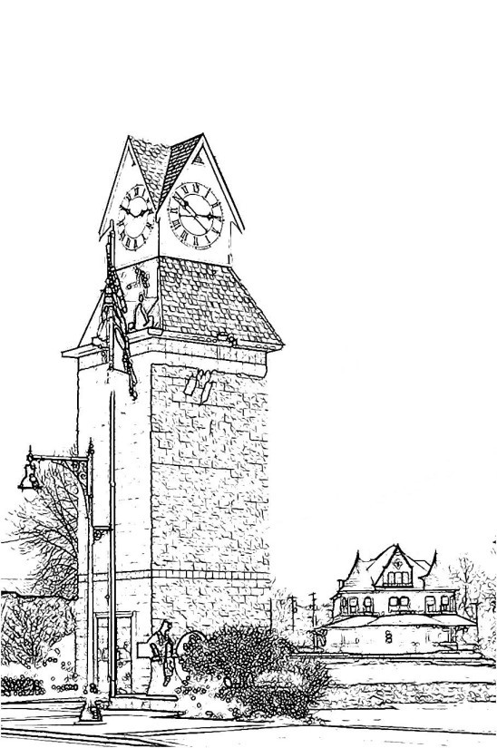
1 - 10 $225.00
11-20 275.00
21-50 295.00
51 - 99 350.00
100 + 425.00
Addl. Business* 50.00
Individuals** – 85.00
Non-Profits 125.00
*Under same ownership
**Non-business

Total Payment: $______________

GREATER DURAND AREA CHAMBER OF COMMERCE
109 N. Saginaw St.
P.O. Box 101
Durand, MI 48429
(989) 288-3715
www.durandchamberofcommerce.com

